Ideation Phase

Define the Problem Statements

|  |  |
| --- | --- |
| Date | 19 September 2022 |
| Team ID | PNT2022TMID09697 |
| Project Name | Skill / Job Recommender |
| Maximum Marks | 2 Marks |

**Problem Statements**

**PS - 1**

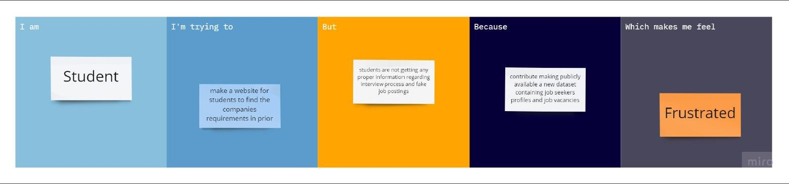

**PS - 2**

